Lab Practical #09:
Study Packet capture and header analysis by Wireshark (HTTP, TCP, UDP, IP, etc.)
Practical Assignment #09:
- Explain usage of Wireshark tool.
- Packet capture and header analysis by Wireshark (HTTP, TCP, UDP, IP, etc.)

Wireshark usage:
- Wireshark is a free and open-source network protocol analyzer.
- It is used to capture and inspect packets flowing in a network in real time.
- Common usages:
  - Troubleshooting network issues.
  - Analyzing protocols (HTTP, TCP, UDP, IP, DNS, etc.).
  - Network security monitoring (checking suspicious traffic).
  - Learning how networking protocols work.

Packet capture and header analysis:

HTTP
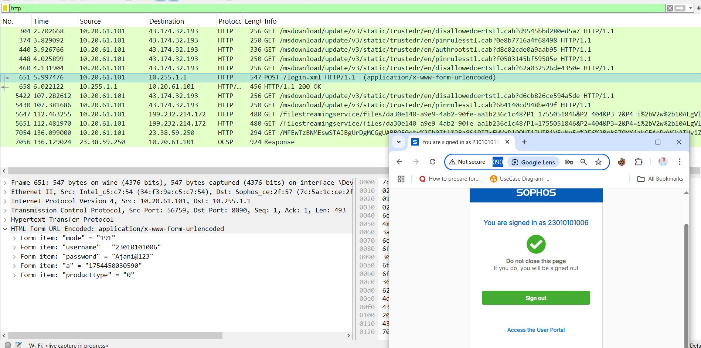

DNS
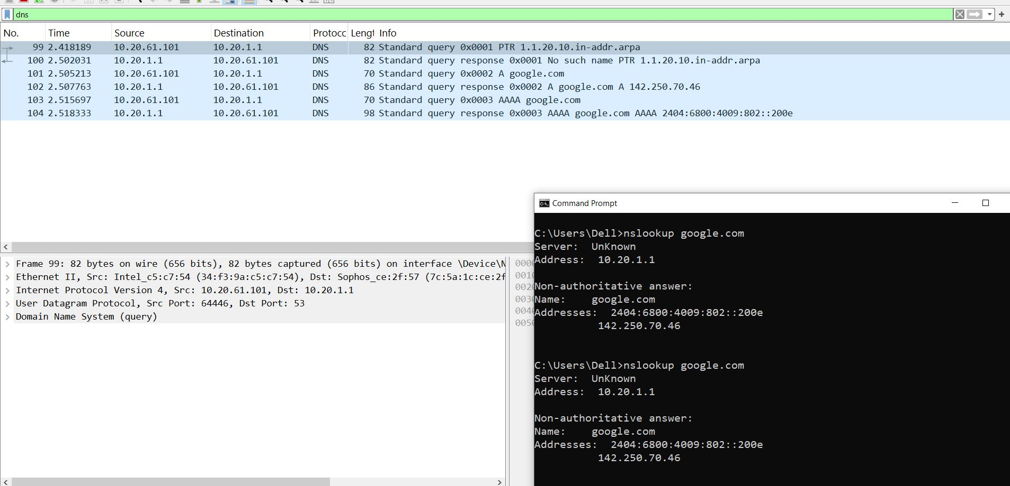

ICMP
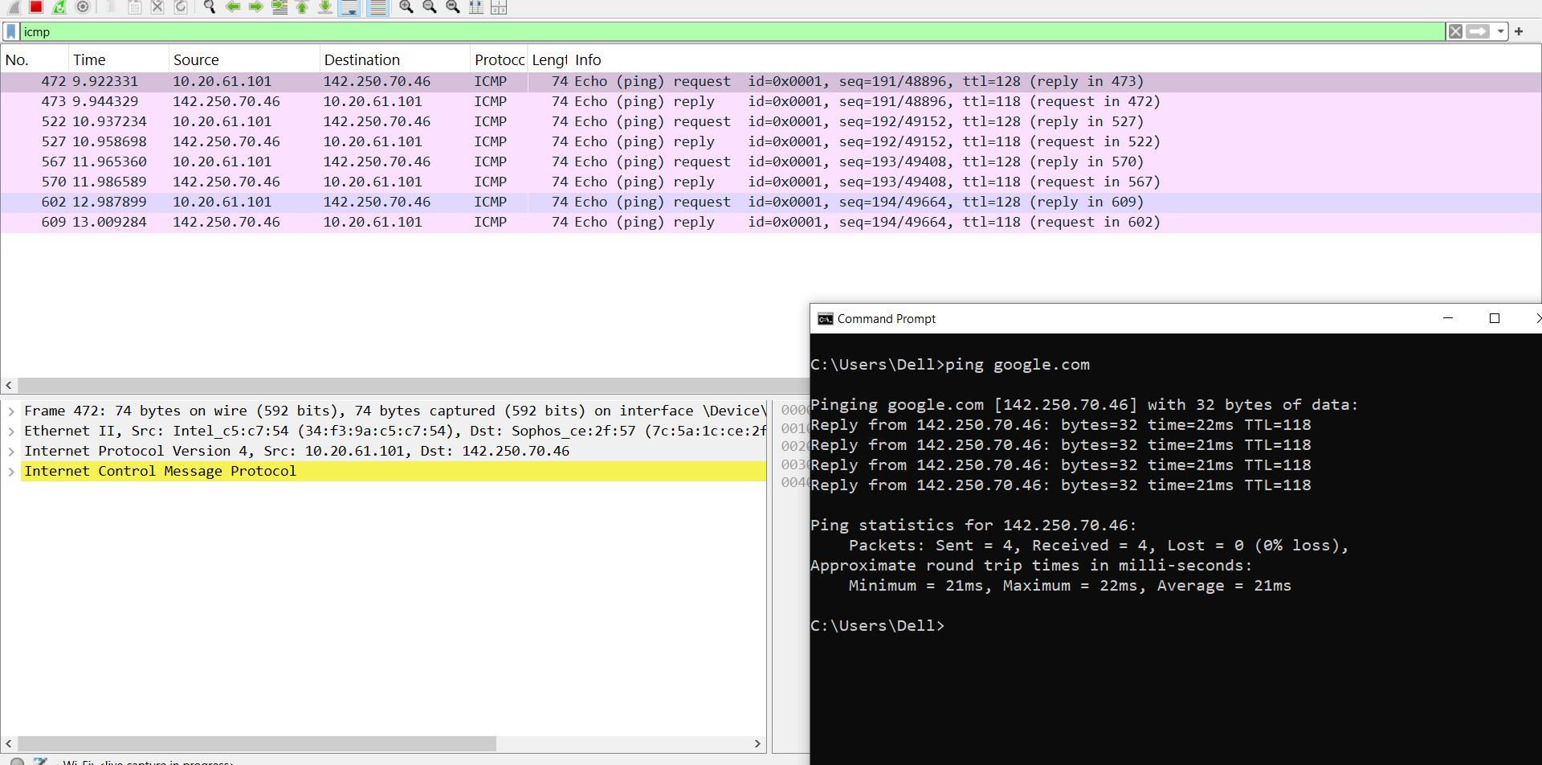

TCP
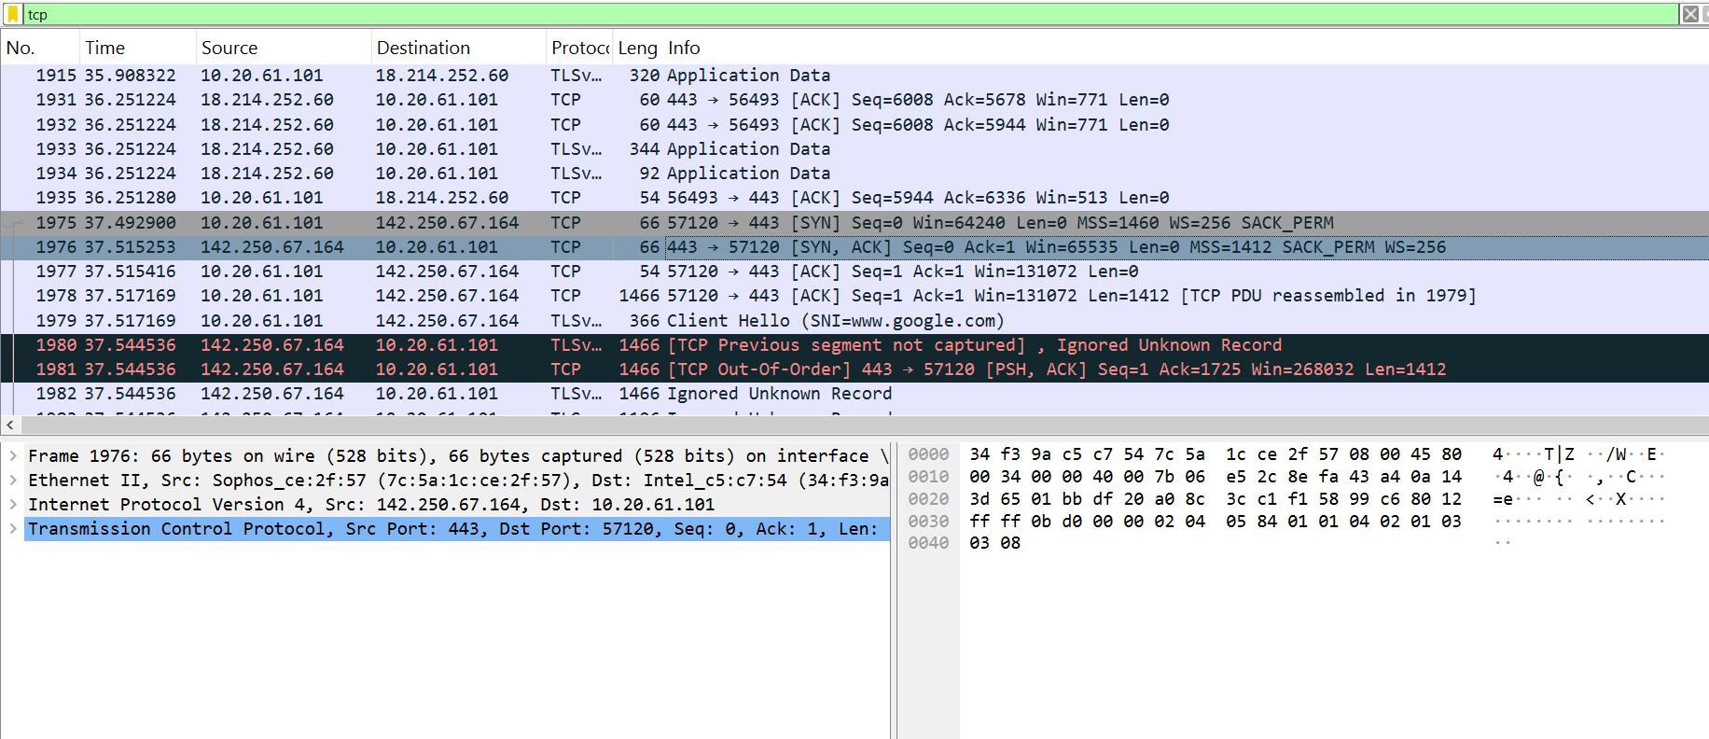

UDP
